Southwest University
School of Computer & Information Science

Experiment Report

Course： Unix/Linux环境实践
Topic ：
Grade&class：Grade 2018 Class SE1
Student Name： 宋行健
Submission Date： 2020年12月7日
第四章课后题（P116）
1. Create a directory in your home directory called projects. In the projects directory, create nine empty files that are named house1, house2, house3, and so on to house9. Assuming there are lots of other files in that directory, come up with a single argument to ls that would list just those nine files.
- 在主目录创建文件夹：mkdir ~/projects/
- 创建多个文件：cd ~/ projects; touch house{1..9}
- 仅展示house开头的文件：ls house{1..9}
2. Make the $HOME/projects/houses/doors/ directory path. Create the following empty files within this directory path (try using absolute and relative paths from your home directory):
$HOME/projects/houses/bungalow.txt
$HOME/projects/houses/doors/bifold.txt
$HOME/projects/outdoors/vegetation/landscape.txt
- 进入HOME目录：cd ~
- 创建文件夹（relative path）：mkdir projects; cd projects/; mkdir houses;
- 创建文件（absolute path）：cd houses/; touch ~/projects/houses/bungalow.txt
- 创建文件夹（absolute path）：mkdir ~/projects/houses/doors
- 创建文件（absolute path）：cd doors/; touch bifold.txt
- 迭代创建文件夹：mkdir -p ~/projects/outdoors/vegetation/
- 创建文件（relative path）：touch ~/projects/outdoors/vegetation/ landscape.txt
3. Copy the files house1 and house5 to the $HOME/projects/houses/ directory.
- cp ~/projects/house[1,2,3,4,5] ~/projects/houses
4. Recursively copy the /usr/share/doc/initscripts* directory to the $HOME/projects/ directory. Maintain the current date/time stamps and permissions.
- cp -ra /usr/share/doc/initscripts*/ ~/projects/
注意：
① -r：如果有目录中有文件，则要使用递归形式
② -a：archive，归档，不改变时间戳（否则文件为新创建的时间）
5. Recursively list the contents of the $HOME/projects/ directory. Pipe the output to the less command so you can page through the output.
- ls -lR ~/projects/ | less
6. Remove the files house6, house7, and house8 without being prompted.
- rm ~/projects/house{6,7,8}
7. Move house3 and house4 to the $HOME/projects/houses/doors directory.
- cd projects; mv house{3,4} houses/doors/
8. Remove the $HOME/projects/houses/doors directory and its contents.
- cd projects; mv house{3,4} houses/doors/
9. Change the permissions on the $HOME/projects/house2 file so it can be readand written by the user who owns the file, only read by the group, and have no permission for others.
- chmod 640 house2
注意：
640：rw- r-- ---
10. Recursively change permissions of the $HOME/projects/ directory so nobody has write permission to any files or directory beneath that point in the filesystem.
- chmod -R a-w projects/
第十一章课后题（P281）
1. Add a local user account to your Linux system that has a username of jbaxter and a full name of John Baxter, and uses /bin/sh as its default shell. Let the UID be assigned by default. Set the password for jbaxter to: My1N1te0ut!
- 创建用户：useradd -c "John Baxter" -s /bin/sh jbaxter
- 设置jbaxter的密码：passwd jbaxter
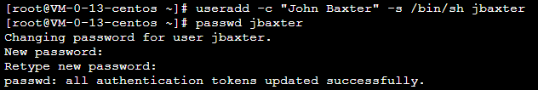
2. Create a group account named testing that uses group ID 315.
- 创建ID为315的用户组：groupadd -g 315 testing
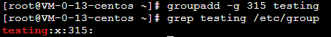
3. Add jbaxter to the testing group and the bin group.
- 将jbaxter用户添加到testing和bin组中：usermod -aG testing,bin jbaxter
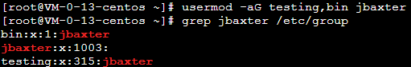
4. Open a shell as jbaxter (either a new login session or using a current shell) and temporarily have the testing group be your default group so that when you type touch /home/jbaxter/file.txt, the testing group is assigned as the file’s group.
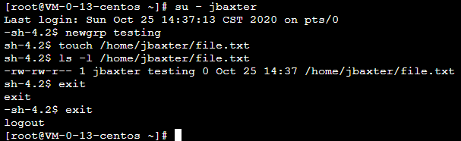
5. Note what user ID has been assigned to jbaxter, and delete the user account without deleting the home directory assigned to jbaxter.
- 查看用户ID：id jbaxter
- 删除用户但不删除其主目录：userdel jbaxter
6. Find any files in the /home directory (and any subdirectories) that are assigned to the user ID that recently belonged to the user named jbaxter.
- 列出/home目录下属于jbaxter （uid为1003）的文件：find /home -uid 1003 -ls
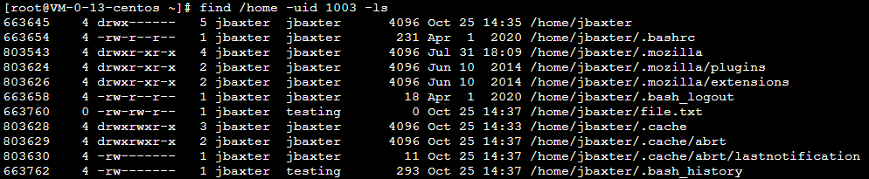
7. Copy the /etc/services file to the default skeleton directory so it shows up in the home directory of any new user. Then add a new user to the system named mjones, with a full name of Mary Jones and a home directory of /home/maryjones.
- cp /etc/services /etc/skel/
- useradd -d /home/maryjones -c "Mary Jones" mjones
- ls -l /home/maryjones
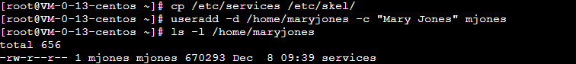
8. Find all files under the /home directory that belong to mjones. Are there any files owned by mjones that you didn’t expect to see?
- find /home -user mjones -ls
- 结果中出现了原本属于jbaxter的文件；
- 查阅资料后，我了解到了原因：在删除用户后user ID 和group ID，这些数字被分配给mjones。
- 注意：在删除用户时要记得把用户的权限一并删除。
9. Log in as mjones, and create a file called /tmp/maryfile.txt. Using ACLs, assign the bin user read/write permission to that file. Then assign the lp group read/write permission to that file.
- [root@VM-0-13-centos ~]# su - mjones
- touch /tmp/maryfile.txt
- setfacl -m u:bin:rw /tmp/maryfile.txt
- setfacl -m g:lp:rw /tmp/maryfile.txt
- getfacl /tmp/maryfile.txt
- ACL（Access Control List）可以针对单一用户、单一文件或目录来进行r,w,x的权限控制，对于需要特殊权限的使用状况有一定帮助。
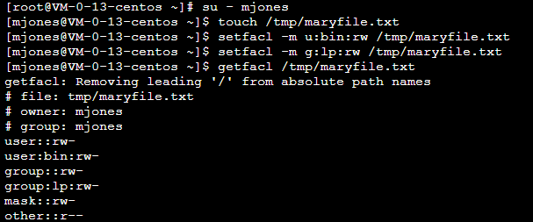
10. Still as mjones, create a directory named /tmp/mydir. Using ACLs, assign default permissions to that directory so the adm user has read/write/execute permission to that directory and any files or directories created in it. Create the /tmp/mydir/testing/ directory and /tmp/mydir/newfile.txt file, and make sure the adm user was also assigned full read/write/execute permissions. (Note that despite assigning rwx permission to the adm user, the effective permission on newfile.txt is only rw. What could you do to make sure ad m gets execute permission as well? )
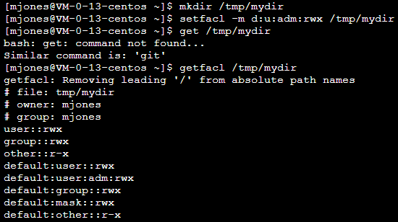
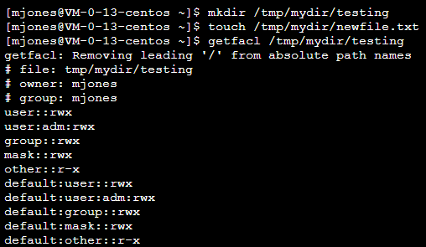
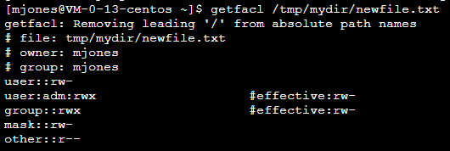
第五章课后题（P134）
1. Copy the /etc/services file to the /tmp directory. Open the /tmp/services file in vim, and search for the term WorldWideWeb. Change that to read World Wide Web.
- 替换：s/WorldWideWeb/ World Wide Web
2. Find the following paragraph in your /tmp/services file (if it is not there, choosea different paragraph) , and move it to the end of that file.
# Note that it is presently the policy of IANA to assign a single well-known
# port number for both TCP and UDP; hence, most entries here have two entries
# even if the protocol doesn't support UDP operations.
# Updated from RFC 1700, "Assigned Numbers" (October 1994). Not all ports
# are included, only the more common ones.
- 剪切光标后的5行：5dd
- 跳转到文章末尾：G
- 粘贴：p
3. Using ex mode, search for every occurrence of the term tcp (case-sensitive) in your /tmp/services file and change it to WHATEVER.
- :g/tcp/s//MYtcp/g
4. As a regular user, search the /etc directory for every file named passwd. Redirecterror messages from your search to /dev/null.
- 文本重定向：find /etc -name passwd 2> /dev/null
5. Create a directory in your home directory called TEST. Create files in that directory named one, two, and three that have full read/write/execute permissions on for everyone (user, group, and other). Construct a find command to find those files and any other files that have write permission open to “others” from your home directory and below.
- 关键命令 find ~ -perm -002 -type f -ls 查找权限为002的一般文件。
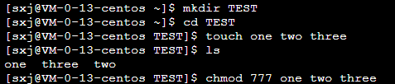
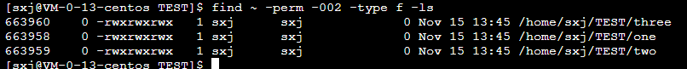
6. Find files under the /usr/share/doc directory that have not been modified in more than 300 days.
- 关键命令 find /usr/share/doc -mtime +300 | head -n 5 查找大于300未修改的文件，并只展示前5条。
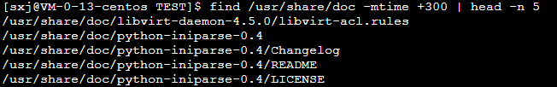
7. Create a /tmp/FILES directory. Find all files under the /usr/share directory that are more than 5MB and less than 10MB and copy them to the /tmp/FILES directory.
- 关键命令 find /usr/share -size +5M -size -10M -exec cp {} /tmp/FILES \; 查找大小为5M至10M的文件，并将其复制到/tmp/FILES（事先创建好的）文件夹下。
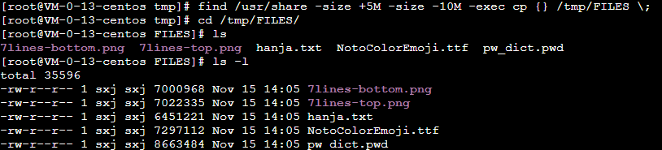
8. Find every file in the /tmp/FILES directory, and make a backup copy of each file in the same directory. Use each file’s existing name, and just append .mybackup to create each backup file.
- 关键命令 find /tmp/FILES -type f -exec cp {} {}.mybackup \; 查找/tmp/FILES文件夹下的普通文件，并使用.mybackup 后缀进行备份。
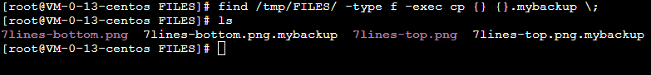
10. Search for the e1000 term again in the same location, but this time list every line that contains the term and highlight the term in color.
- 关键命令 grep -ri –color e1000 查找包含“e1000”的内容，并使用不同的颜色进行突出展示。
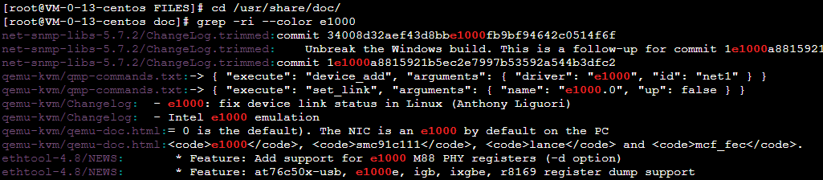
第六章课后题（P151）
1. List all processes running on your system, showing a full set of columns. Pipe that output to the less command so you can page through the list of processes.
- ps -ef 显示所有进程
- 列出系统上运行的所有进程，使用less命令的管道可以进行翻页查看：ps -ef | less
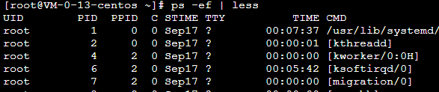
2. List all processes running on the system, and sort those processes by the name of the user running each process.
- 列出系统上的所有进程，使用sort对结果按照user进行排序：ps -ef --sort=user | less
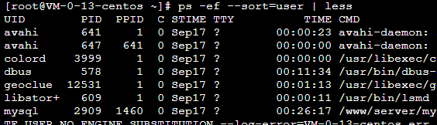
3. List all processes running on the system, and display the following columns of information: process ID, user name, group name, virtual memory size, resident memory size, and the command.
- -e显示所有进程，-o指定命令的名字
- ps -eo 'pid,user,group,nice,vsz,rss,comm' | less
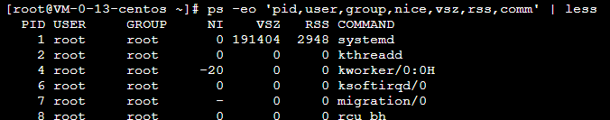
4. Run the top command to view processes running on your system. Go back and forth between sorting by CPU usage and memory consumption.
- top命令是Linux下常用的性能分析工具，能够实时显示系统中各个进程的资源占用状况，类似于Windows的任务管理器。
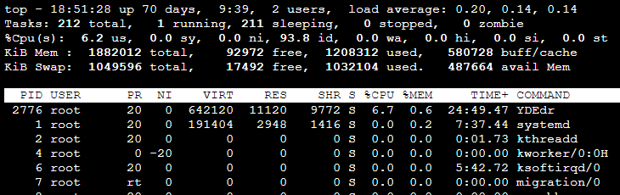
5. Start the gedit process from your desktop. Make sure you run it as the user you are logged in as. Use the System Monitor window to kill that process.
- 1~4题的操作平台是腾讯云服务器 Cent OS 7，本题需要使用桌面操作，因此操作平台改到了Ubuntu虚拟机。
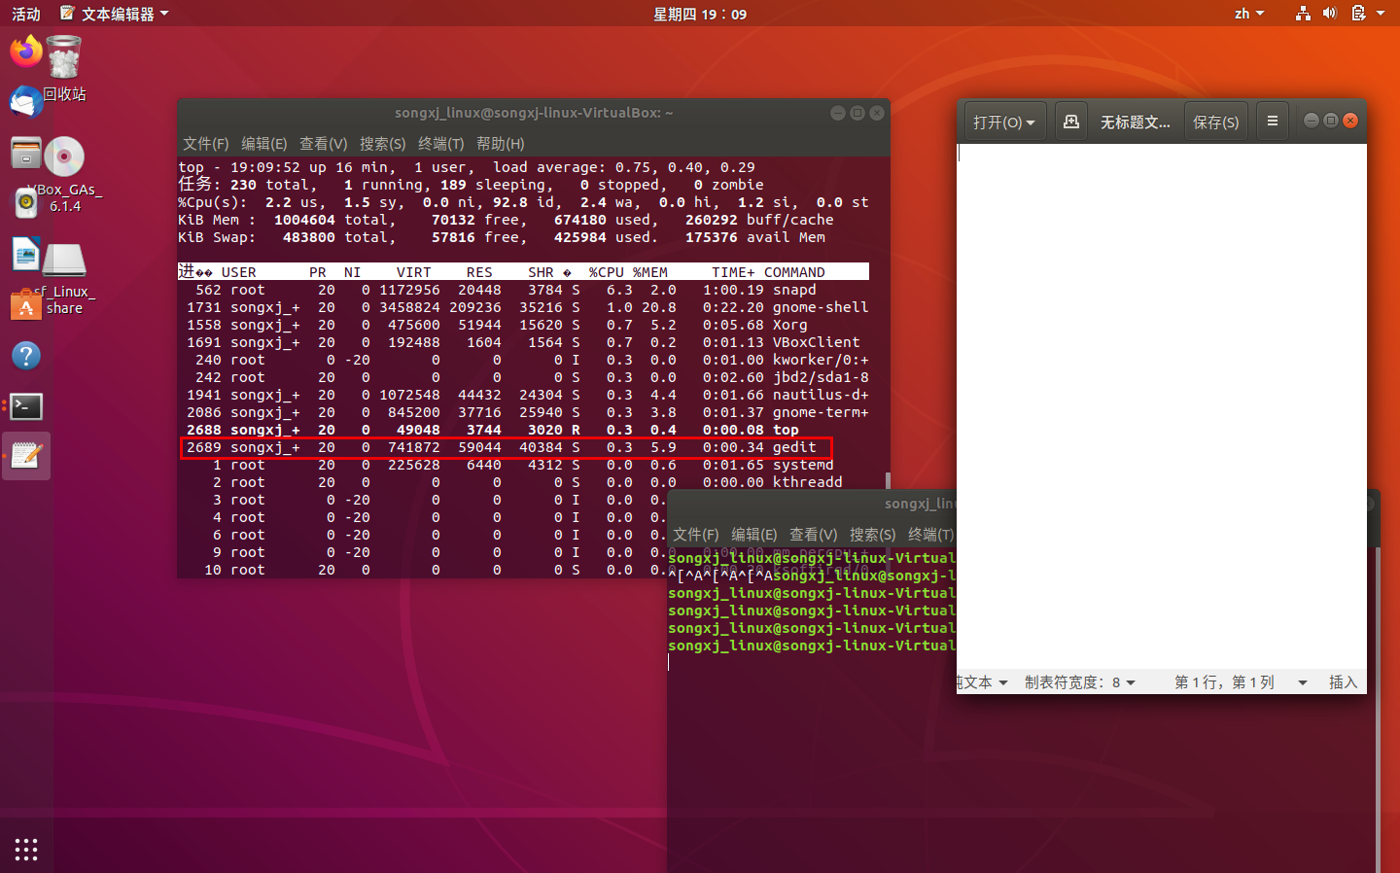
6. Run the gedit process again. This time, using the kill command, send a signal to the gedit process that causes it to pause (stop). Try typing some text into the gedit window and make sure that no text appears yet.
- 将程序暂停：kill -SIGSTOP 2689 其中，2689为gedit的PID，运行这个命令后文本编辑框无法点击，类似程序卡住的现象。
7. Use the killall command to tell the gedit command you paused in the previous exercise to continue working. Make sure the text you type in after gedit was paused now appears on the window.
- 将暂停的程序继续：killall -SIGCONT gedit 运行这个命令后，文本编辑框可以继续编辑。
8. Install the xeyes command (in Red Hat Enterprise Linux, it is in the xorg-x11-apps package). Run the xeyes command about 20 times in the background so that 20 xeyes windows appear on the screen. Move the mouse around and watch the eyes watch your mouse pointer. When you have had enough fun, kill all xeyes processes in one command using killall.
- xeyes; xeyes; xeyes; killall xeyes;
9. As a regular user, run the gedit command so it starts with a nice value of 5.
- nice -n 5 gedit &;
- 这里在命令最后加“&”号，是显示进程的PID。
10. Using the renice command, change the nice value of the gedit command you just started to 7. Use any command you like to verify that the current nice value for the gedit command is now set to 7.
- 修改进程的nice值：renice -n 7 2985;
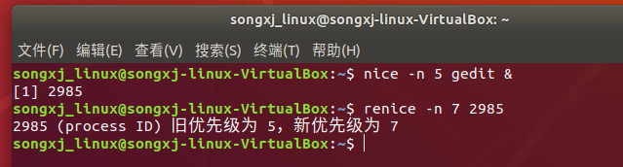
Score：

Teacher（signature）：

Date:

